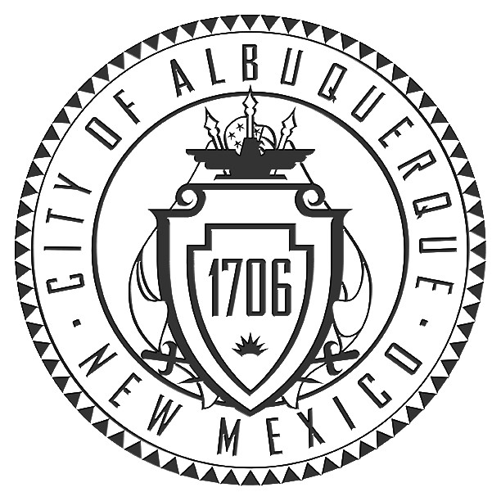
Office of the City Clerk

P.O. Box 1293
Albuquerque, NM 87103
Phone (505) 768-3030 Fax (505) 768-2845

Amy B. Bailey, City Clerk

BOARD OF ETHICS
&
CAMPAIGN PRACTICES

NOTICE OF MEETING

Notice is hereby given that the Board of Ethics & Campaign Practices has scheduled a meeting for Friday, August 12, 2011, beginning at 4:00 P.M., in the VINCENT E. GRIEGO CHAMBERS, basement level of the City/County Building, to hear:

- Candidates and Treasurers Orientation

- Measure Finance Committees Orientation

Except for any portion of the meeting that may be closed by the Board pursuant to the provisions of the New Mexico Open Meetings Act, the meeting will be open to the public.

Any disabled member of the public who wishes to attend the meeting and needs accommodations to attend or participate, such as sign language, interpretation, an amplifier, a reader or other form of accommodations, should contact Jeanette R. Lovato at 768-3061, at least 5 days prior to the meeting. Also, disabled persons who need public documents such as meeting agendas, etc., in accessible format should contact Jeanette R. Lovato.

POSTED AT CITY HALL AND THE CITY CLERK’S OFFICE

Posted 08/01/2011

